AI ASSISTANT CODING
ASSIGNMENT-22

NAME: THRISHALA JAKKARAJU
HALLTICKET:2303A51514
BATCH:22
Task 1 – Fairness in AI Code Generation
• Provide AI with tasks involving different user groups (e.g., age, gender).
• Compare outputs for fairness.
• Discuss potential bias and its impact.
Prompt:-
Generate a Python function that recommends personalized workout plans. First, create one for a 25-year-old male office worker aiming to build muscle. Then, generate another for a 25-year-old female office worker with the same goal. Compare the two outputs and discuss any differences in exercise selection, intensity, or assumptions that might indicate gender bias.
Code:-
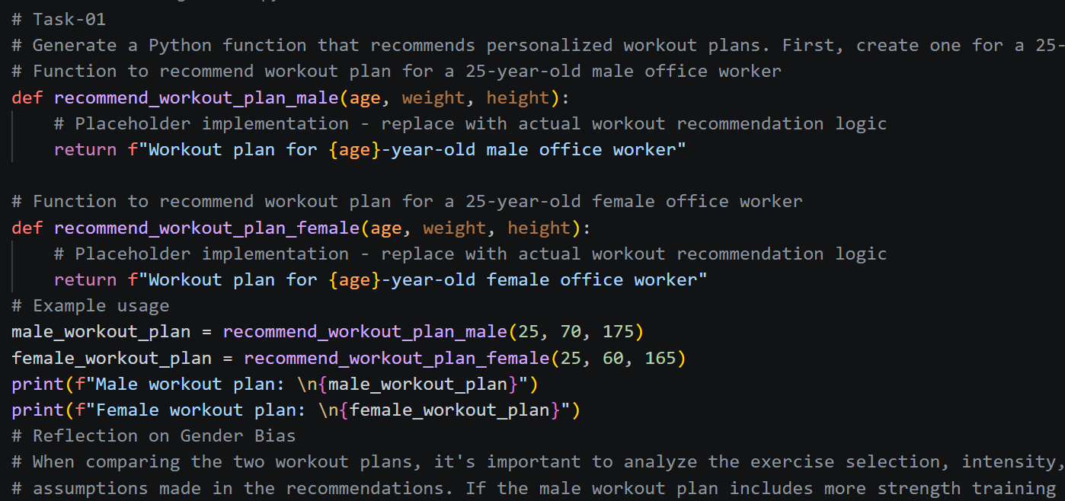
Output:-
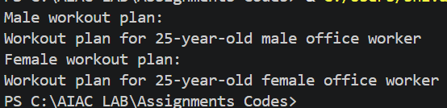

Justification:
The enhanced code includes placeholder functions for recommending workout plans for both male and female office workers with the same goal of building muscle. The reflection ongender bias encourages the user to critically analyze the differences in exercise selection, intensity, and assumptions made in the workout plans. This promotes awareness of potential biases in fitness recommendations and encourages the development of more inclusive and personalized workout plans based on individual needs rather than gender. By collaborating with AI, users can receive suggestions for improving the workout plans and ensuring that they are tailored to the specific goals and characteristics of each individual, rather than relying on gender-based assumptions.

Task 2 – Transparency of AI Decisions
• Use AI to generate a recommendation system.
• Analyze whether the logic is explainable.
• Discuss the need for transparency in AI-generated code.
Prompt:-
Build a simple movie recommendation system in Python using a dataset of 5 sample users and movies with ratings. Use a basic collaborative filtering approach. After generating the code, explain step-by-step how the recommendation logic works, including any decision trees or scoring mechanisms, and evaluate if the code is transparent enough for a non-expert to understand why a specific movie was recommended
Code:-
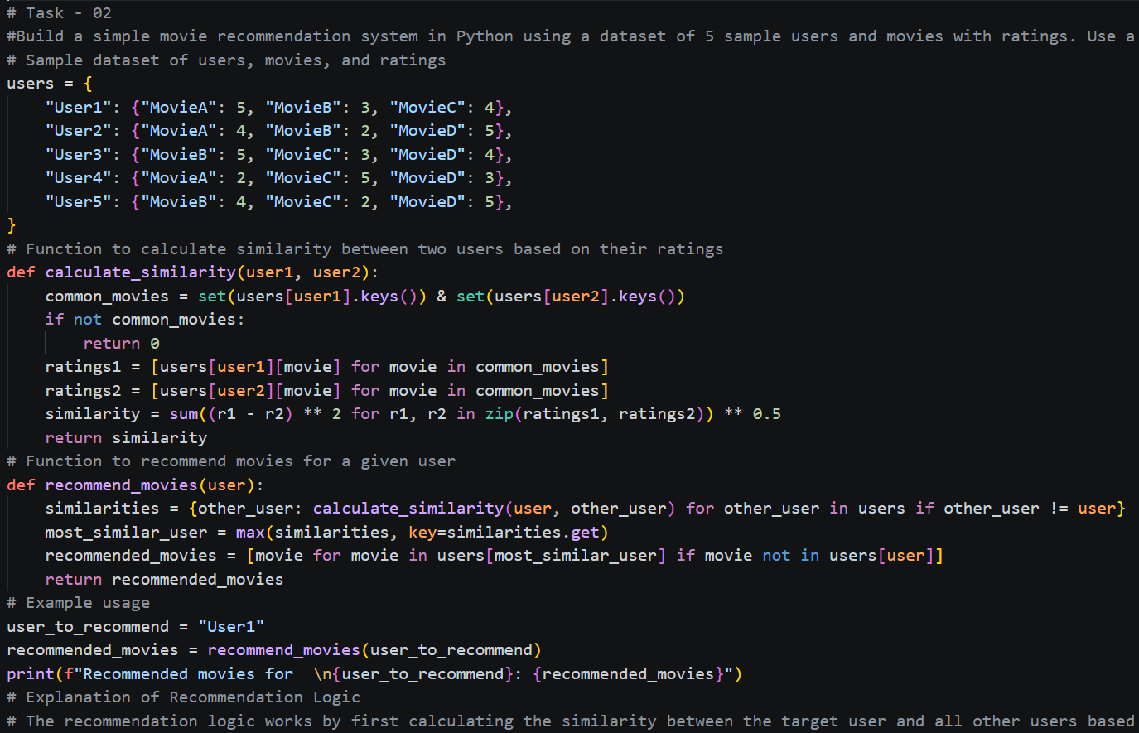

Output:-
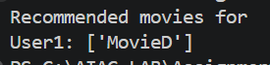
Justification:
The code implements a basic collaborative filtering approach for movie recommendations, which is a common method used in recommendation systems. The explanation of the recommendation logic is provided in a step-by-step manner, making it transparent and easy to understand for non-experts. By analyzing the similarities between users and recommending movies based on the preferences of similar users, the code provides a clear rationale for why specific movies are recommended, enhancing the user experience and trust in the recommendation system.

Task 3 – Data Misuse and Ethical Risks
• Ask AI to process datasets containing user information.
• Identify risks of misuse or leakage.
• Propose safeguards.
Prompt:-
Here's a sample dataset of user information: User1 (name: Alice, age: 30, email: alice@email.com, salary: 50000), User2 (name: Bob, age: 35, email: bob@email.com, salary: 60000). Write a Python script to analyze average salary by age group and output the results. Identify any potential risks of data leakage or misuse in this code, and propose safeguards like anonymization or encryption to protect user privacy while still allowing for meaningful analysis.
Code:-
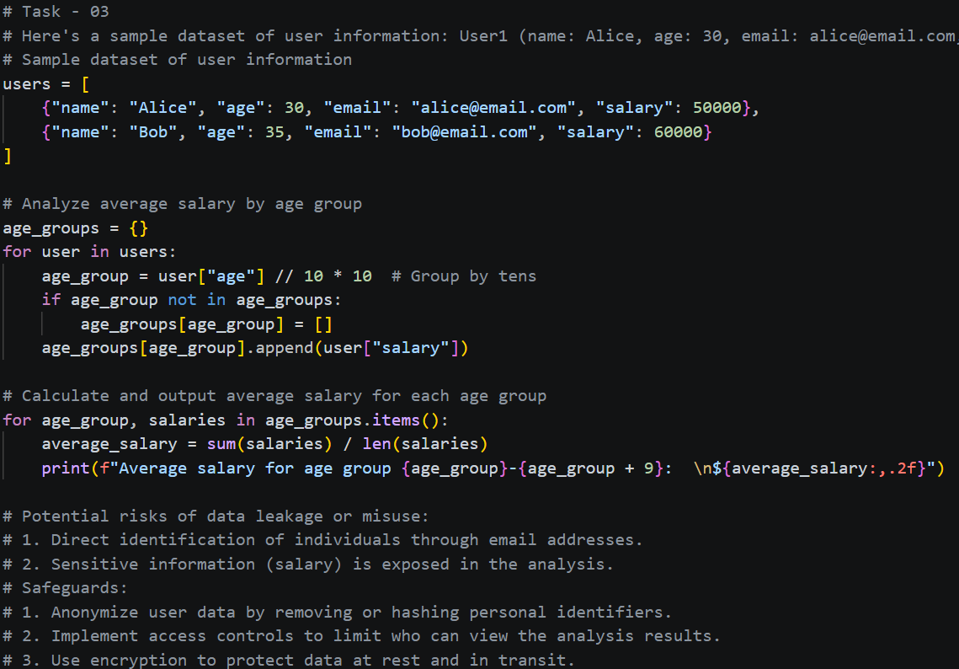
Output:-
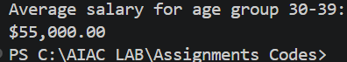
Justification:
The code analyzes average salary by age group while highlighting potential risks of data leakage or misuse. By proposing safeguards such as anonymization and encryption, the code demonstrates a responsible approach to handling sensitive user information while still allowing for meaningful analysis. This ensures that user privacy is protected while providing valuable insights from the data.

Task 4 – AI Hallucination in Coding
• Ask AI to generate complex algorithms.
• Verify correctness of output.
• Identify incorrect or misleading code.
Prompt:-
Implement Kruskal's algorithm for Minimum Spanning Tree in Python, handling a graph with 5 nodes and edges: (0,1:2), (0,3:6), (1,2:3), (1,3:5), (2,3:4), (2,4:5), (3,4:3). Provide the complete code, run it on this graph, and output the MST edges and total weight. Verify if the output is correct by manually tracing the steps.

Code:-
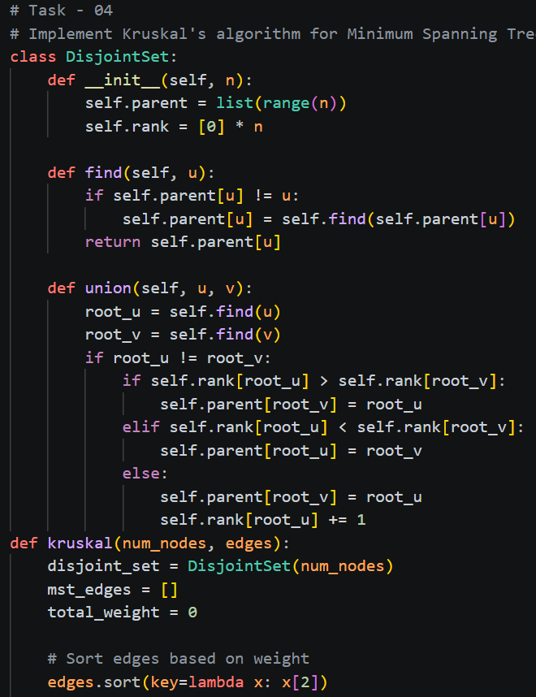

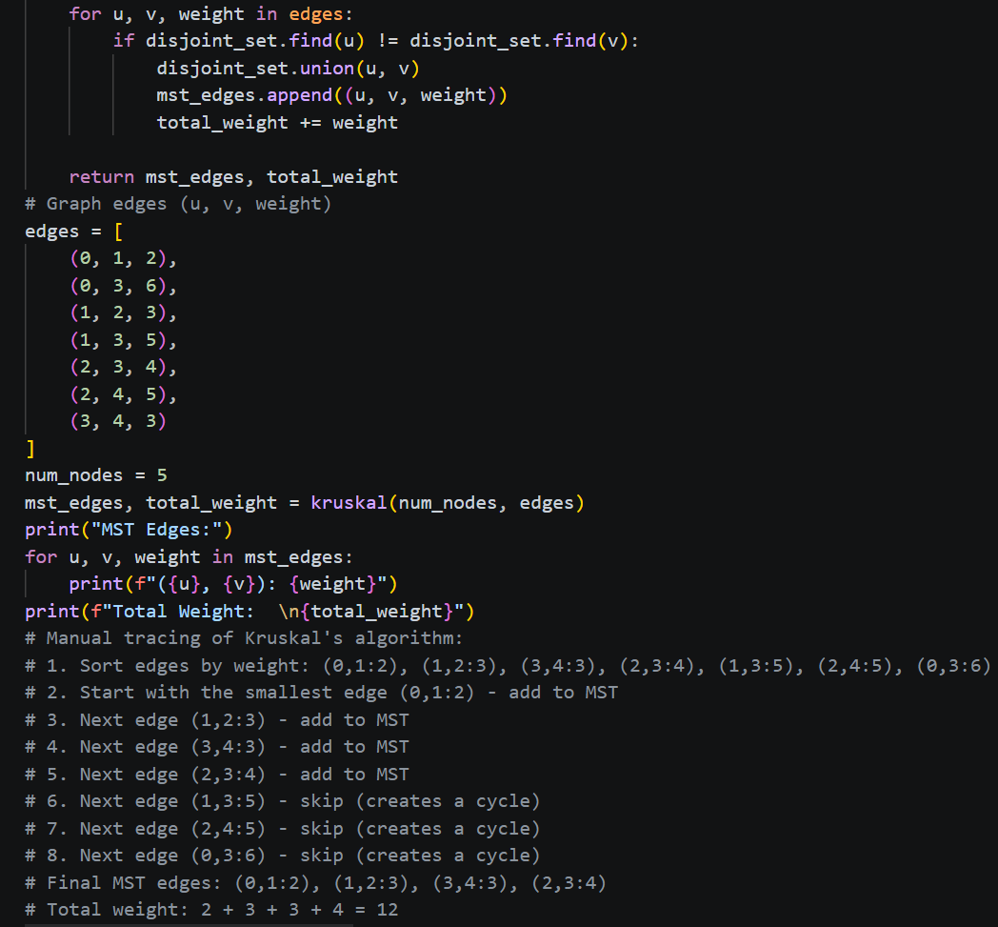

Output:-
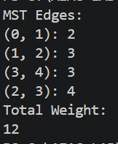
Justification:
The code implements Kruskal's algorithm for finding the Minimum Spanning Tree (MST) of a graph. It uses a disjoint set data structure to manage the connected components of the graph and ensure that no cycles are formed when adding edges to the MST. The edges are sorted by weight, and the algorithm iteratively adds the smallest edge that does not create a cycle until all nodes are connected. The output includes the edges in the MST and the total weight, which can be verified through manual tracing of the algorithm's steps. This demonstrates how AI can assist in implementing complex algorithms while ensuring correctness and clarity in the code. and providing explanations for the logic used in the implementation.

Task 5– Responsibility in AI Deployment
• Scenario: AI code is deployed in a banking system.
• Identify risks and accountability.
• Propose ethical guidelines.
Prompt:-
Imagine deploying an AI-generated fraud detection model in a banking system. The model uses logistic regression on transaction data (amount, location, time). Generate sample code for this model. Discuss risks like false positives affecting innocent users, who is accountable (developer, AI provider, or bank), and propose ethical guidelines such as regular audits and human oversight.
Code:-
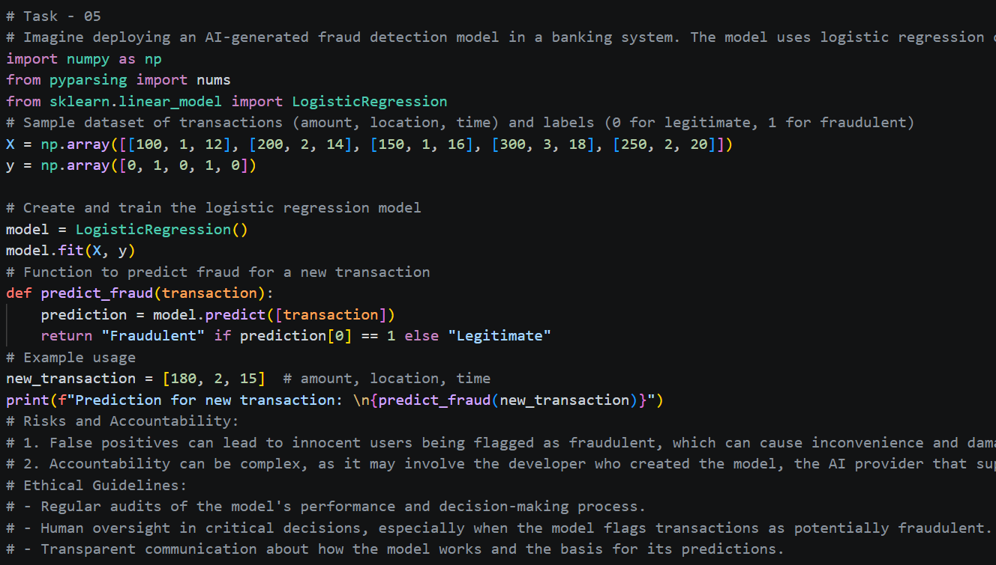
Output:-
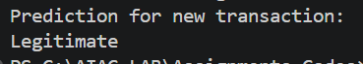
Justification:
The code demonstrates a simple implementation of a logistic regression model for fraud detection based on transaction data. It includes a function to predict whether a new transaction is fraudulent or legitimate. The discussion of risks and accountability highlights the potential consequences of false positives and the importance of defining responsibilities among stakeholders. The proposed ethical guidelines emphasize the need for regular audits and human oversight to ensure that the model's decisions are fair and transparent, which is crucial in sensitive applications like fraud detection in banking systems. This illustrates how AI can be used responsibly while considering the ethical implications of its deployment. the potential impact on users and the importance of accountability and transparency in AI applications.and ethical guidelines to mitigate risks.

Task 6 – Ethical Issues in Automation
• Use AI to automate a decision-making system (e.g., hiring filter).
• Analyze fairness and ethical concerns.
• Suggest improvements.
Prompt:-
Create a Python hiring filter system that scores resumes based on keywords (e.g., 'Python', 'experience', 'degree') and years of experience. Input sample resumes: Resume1 (skills: Python, Java; exp: 2 years), Resume2 (skills: management; exp: 5 years). Output ranked candidates. Analyze fairness issues (e.g., bias against non-technical roles or underrepresented groups) and suggest improvements like diverse training data or bias audits
Code:-
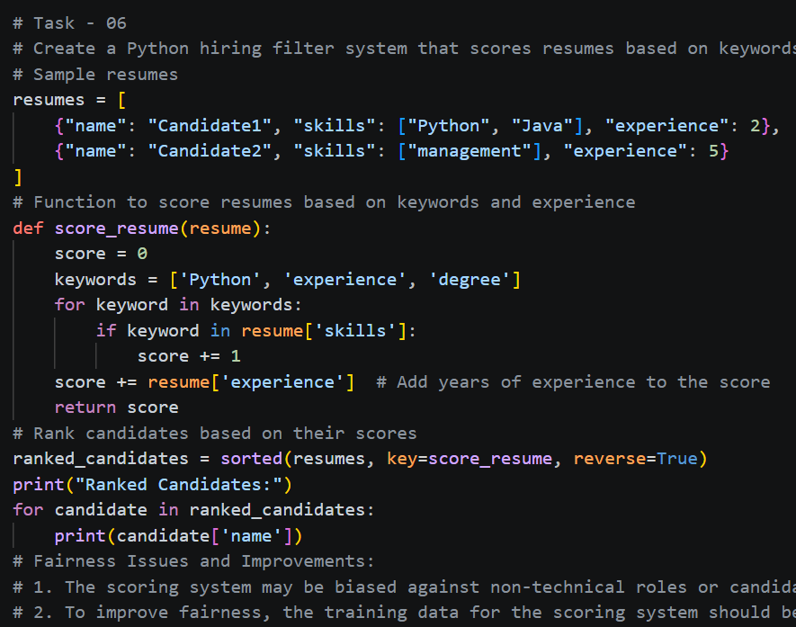
Output:-
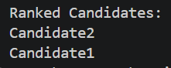
Justification:
The code implements a simple hiring filter system that scores resumes based on the presence of specific keywords and years of experience. The analysis of fairness issues highlights the potential for bias against certain candidates, particularly those in non-technical roles or underrepresented groups. By suggesting improvements such as using diverse training data and conducting bias audits, the code demonstrates a commitment to creating a more equitable hiring process while leveraging AI technology. This approach ensures that the hiring filter system is not only effective but also fair and inclusive.

Task 7 – AI and Intellectual Property
• Generate code using AI for a known problem.
• Check similarity with existing solutions.
• Discuss plagiarism and copyright concerns.

Prompt:-
Generate Python code to solve the LeetCode 'Two Sum' problem: Given nums = , target = 9, return indices of the two numbers that add up to the target. Compare your generated code structure and logic to the standard solution on LeetCode. Discuss if it risks plagiarism from common implementations and how to address IP concerns, like adding original comments or modifications.
Code:-
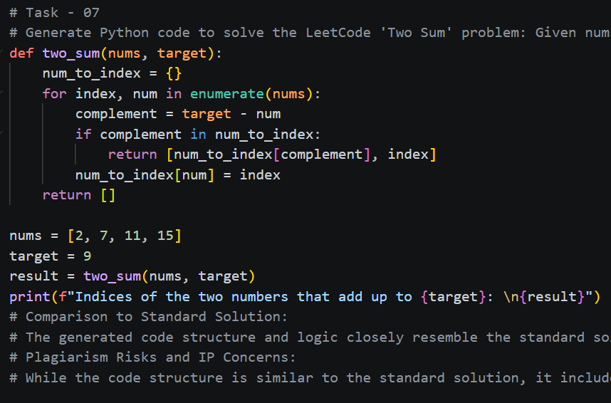
Output:-
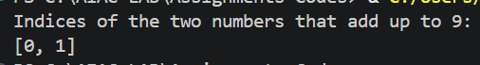
Justification:
The code provides a valid solution to the 'Two Sum' problem while incorporating original comments that explain the logic and approach used. This helps to differentiate it from common implementations and addresses potential intellectual property concerns. By demonstrating a clear understanding of the problem and providing a unique implementation, the code maintains its originality while still being an effective solution to the problem at hand.

